- Watch ansible-01 video and write down notes.
Completed
- Setup one master and two worker nodes in ansible.
Ansible-controller and two workers ec2 created with ubuntu ami.
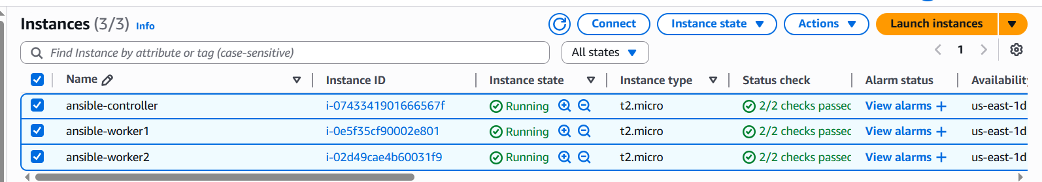
Ansible Master:ec2
python3 –version To check available or not then install.
ansible –version To check available or not then install.
apt update First update the server.
apt install ansible To install ansible.
Cd /opt/
Mkdir ansible
Cd ansible/
Add in the master machine
cd /etc/ansible/
vi ansible.cfg
[defaults]
inventory = /etc/ansible/host
host_key_checking = False
retry_files_enabled = False
forks = 10

touch hosts
vi host
[all]
172.31.28.133
172.31.29.235
[node-1]
172.31.28.133
[node-2]
172.31.29.235

create ssh-keygen in master machine to make connectivity in the ubuntu/root.
Cat <public-ip path>
Ansible node-1&2:ec2
Paste the public key cd .ssh/ --> ls --> authorized_key --> vi authorized_key
same follow for both users.
Login to root/ubuntu user
outcome in the master server:
ansible all –m ping

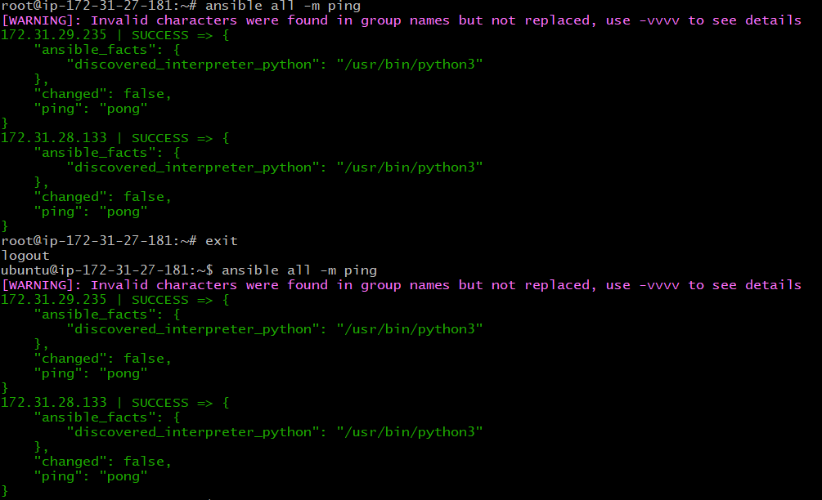

- Execute the adhoc command shared in #dvps-cloud-documents-14 Channel.
Gather facts of slave machine:
ansible all -m setup
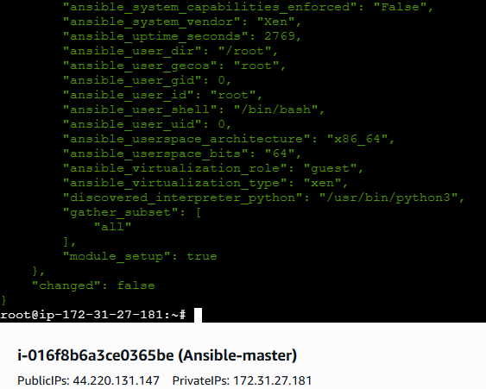

🔹 On the Managed Node (ansible-worker1)

1. Create a new user
sudo adduser ansadm
👉 It will ask you to set a password. Choose a strong one.

2. Allow this user to use sudo (optional, if you want to run privileged tasks)
sudo usermod -aG sudo ansadm

3. Enable password authentication in SSH
Open the SSH config file:
sudo nano /etc/ssh/sshd_config
Make sure these lines are set:
PasswordAuthentication yes
ChallengeResponseAuthentication no
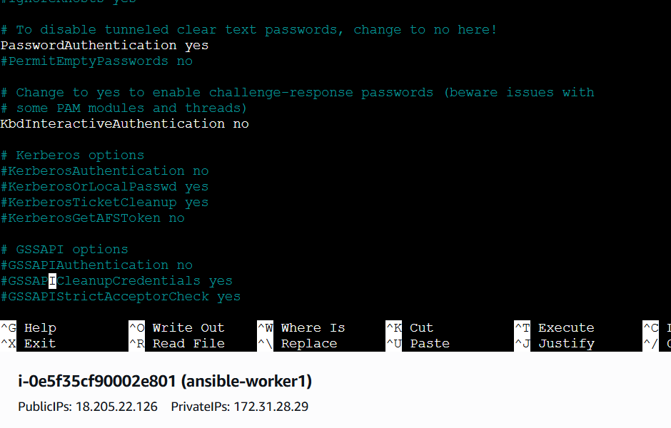
ave & exit (CTRL+O, Enter, CTRL+X).
4. Restart SSH service
sudo systemctl restart ssh
Now ansadm can log in with a password.

🔹 On the Control Node (ansible-master)

5. Test SSH manually (ensure it works)
ssh ansadm@<WORKER1_IP>
# TO checkthe uptime of a slave machine
ansible all -a uptime
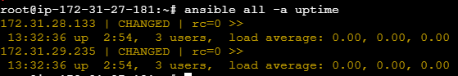
# check the free memory or memory usage of host
ansible all -a "free -m"
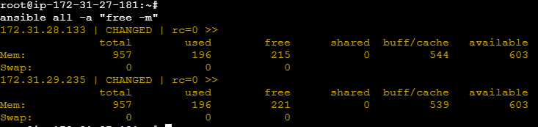
# Execute a command using become module
ansible all -m shell -a "cat /etc/passwd|grep -i ansadm" -b -K
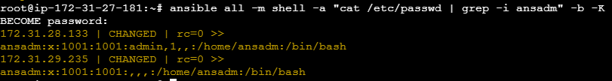
Create a Linux group
ansible all -m group -a "name=test state=present" -b -K

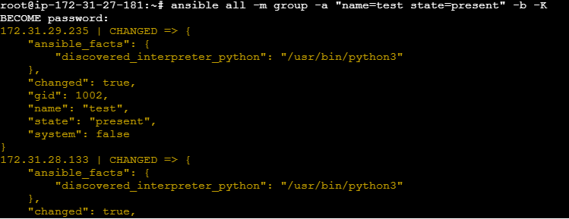
Create a file with 755 permissions
ansible all -m file -a "path=/home/ansadm/testfile state=touch mode=0755" –b –become-user=ansadm
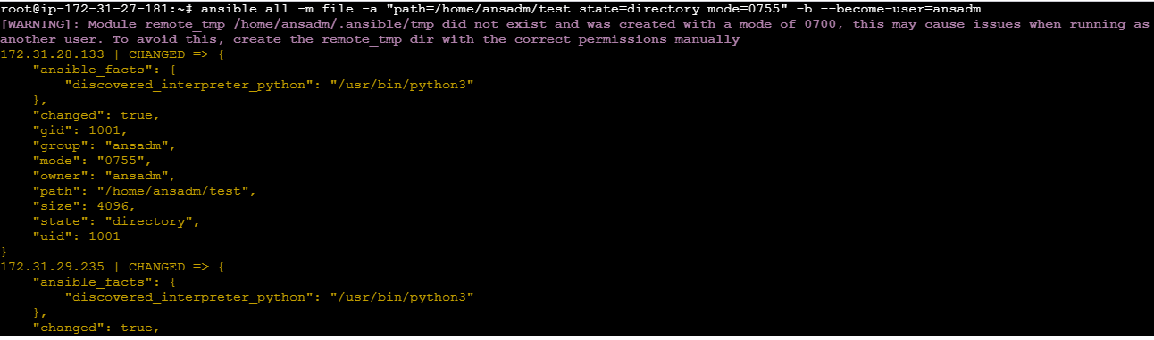
# Create a Linux user group
ansible all -s -m group -a "name=test state=present" -b -K
